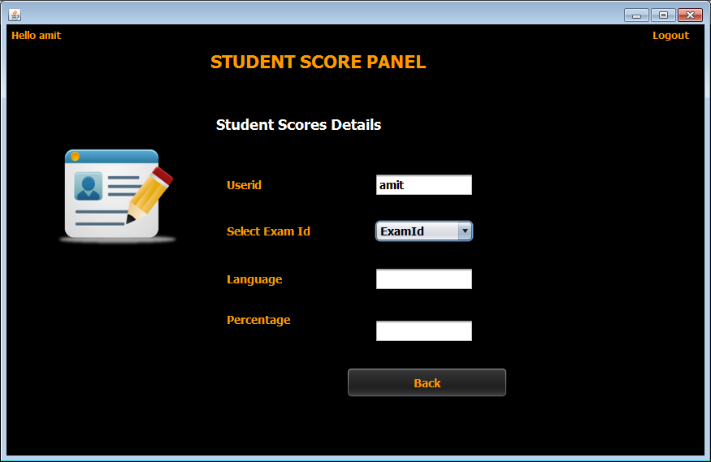

**STEPS TO BE DONE IN** **ViewStudentScoreFrame**

In the **ViewStudentScoreFrame** we need to do following steps:

1. Handle the constructor for proper initialization of class members as well as load the UI with student name as well as the **JComboBox** with the exams he has appeared for.

2. Write code for the displaying Student score as soon as he selects any exam id in the **JComboBox** .

**HOW SHOW EXAM ID IN THE JCOMBOBOX:**

The first step we need to do in the **constructor** of **ViewStudentScoreFrame** is to load all the **exam id** in the **JComboBox** .

To do this we will create a method called **loadUI( )** in the **ViewStudentScoreFrame** and call it from the constructor.

***public void loadUI(){***

***txtUserid.setText(UserProfile.getUSername());***

***isAdding=true;***

***jcExamId.removeAllItems();***

***jcExamId.addItem("ExamId");***

***for(String exid: examIdList)***

***jcExamId.addItem(exid);***

***isAdding=false;***

***}***

***public class ViewStudentScoreFrame extends javax.swing.JFrame {***

***private boolean isAdding;***

***private ArrayList<String>examIdList;***

***public ViewStudentScoreFrame() {***

***initComponents();***

***lblUsername.setText("Hello "+UserProfile.getUSername());***

***}***

***public ViewStudentScoreFrame(ArrayList<String>examIdList) {***

***this();***

***this.examIdList=examIdList;***

***loadUI();***

***}***

**HOW SHOW THE STUDENT SCORE:**

To show the student score as soon as the user selects an exam id , we will do the following:

**a. Create the Action Event for the JComboBox**

**b. Validate whether user has selected an exam id or not. If he has not selected any exam id then display an error message.**

**c. Call the method getScore( ) of the class PerformanceDAO. This method accepts a student id and exam id as argument and fetches and returns his percentage and language name as an object of the class StudentScore from the table PERFORMANCE. The prototype of this method will be:**

***public static StudentScore getScore(String studentId,String examId)throws SQLException***

Following is the code:

***public static StudentScore getScore(String studentId,String examId)throws SQLException{***

***String qry="Select language,per from Performance where userid=? and examid=?";***

***Connection conn=DBConnection.getConnection();***

***PreparedStatement ps=conn.prepareStatement(qry);***

***ps.setString(1,studentId);***

***ps.setString(2,examId);***

***ResultSet rs=ps.executeQuery();***

***rs.next();***

***StudentScore scoreObj=new StudentScore();***

***scoreObj.setLanguage(rs.getString(1));***

***scoreObj.setPer(rs.getDouble(2));***

***return scoreObj;***

***}***

***private void jcExamIdActionPerformed(java.awt.event.ActionEvent evt) {***

***if(isAdding==true){***

***return;***

***}***

***String examId=jcExamId.getSelectedItem().toString();***

***if(examId.equals("ExamId"))***

***{***

***JOptionPane.showMessageDialog(null, "Please select an ExamId!","No ExamId Selected!!",JOptionPane.INFORMATION_MESSAGE);***

***return;***

***}***

***try***

***{***

***StudentScore scoreObj=PerformanceDAO.getScore(UserProfile.getUSername(), examId);***

***txtLanguage.setText(scoreObj.getLanguage());***

***txtPercentage.setText(String.valueOf(scoreObj.getPer()));***

***}***

***catch(SQLException ex)***

***{***

***JOptionPane.showMessageDialog(null, "Error while connecting to DB!","Exception!",JOptionPane.ERROR_MESSAGE);***

***ex.printStackTrace();***

***}***

***}***